Term-2 Year-2 Reference Resource

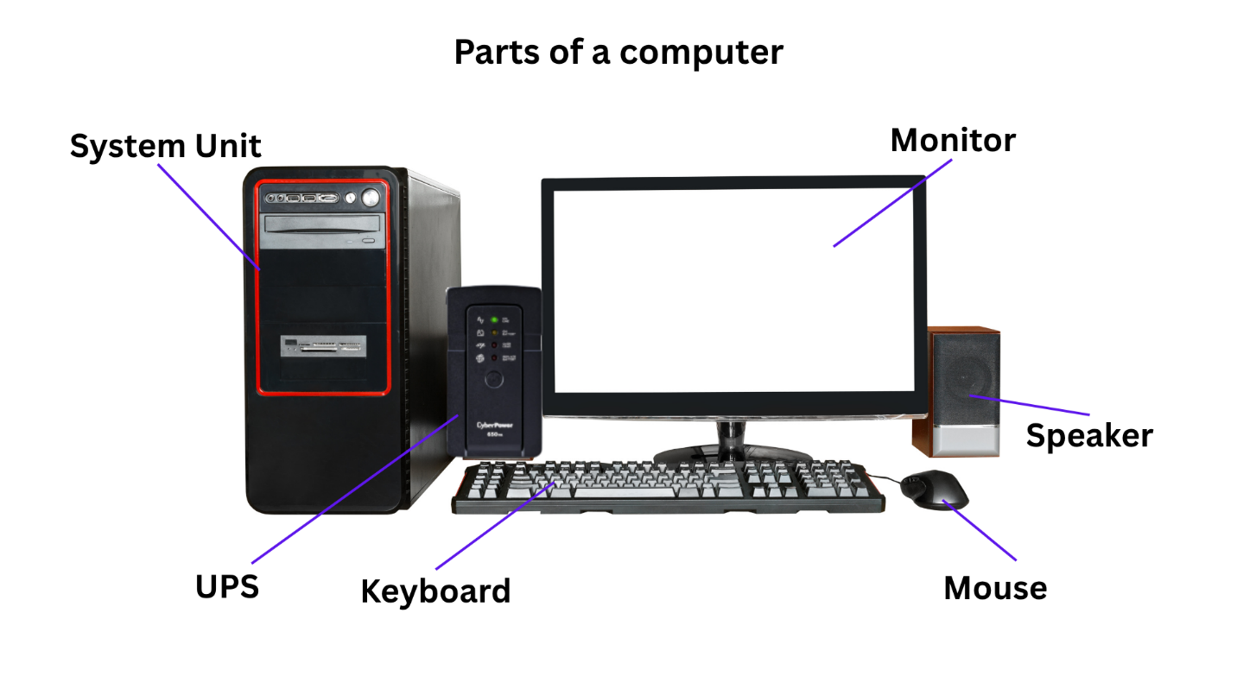

Computer System
A computer system is a set of parts that work together to do different jobs.
It helps us type, draw, play games, watch videos, and search the internet.

A computer system = Hardware + Software + People (Users)

Hardware
Hardware is the physical parts of a computer — the things we can see and touch.
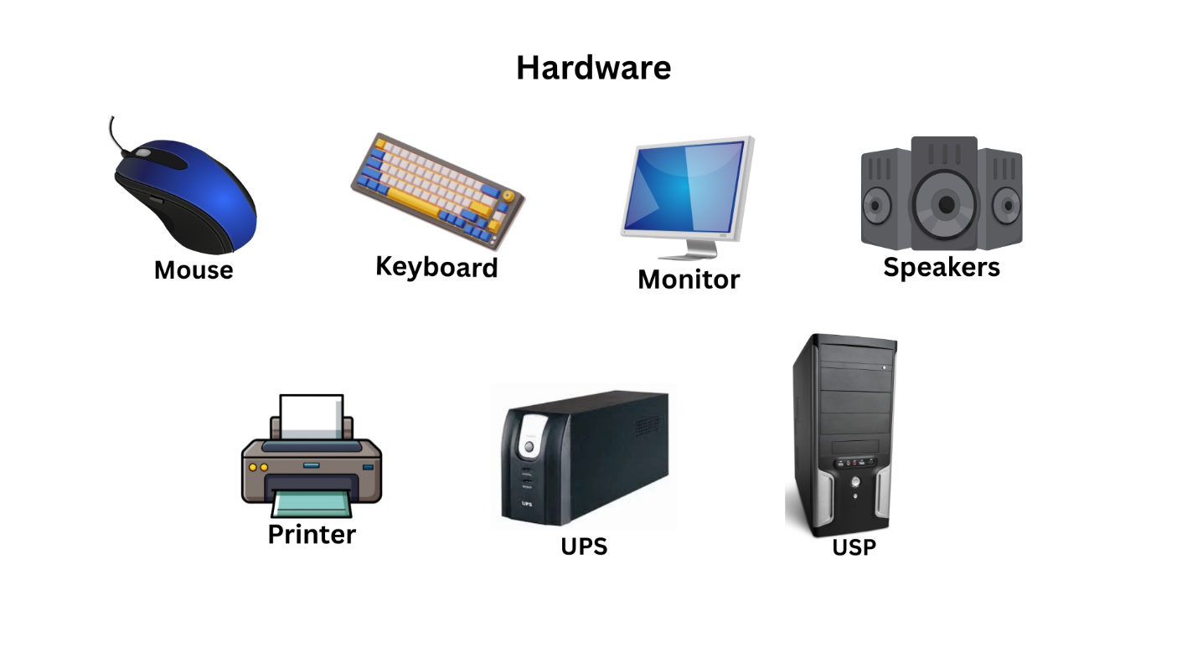
Software
Software is the set of programs or instructions that tell the computer what to do. We cannot touch software.
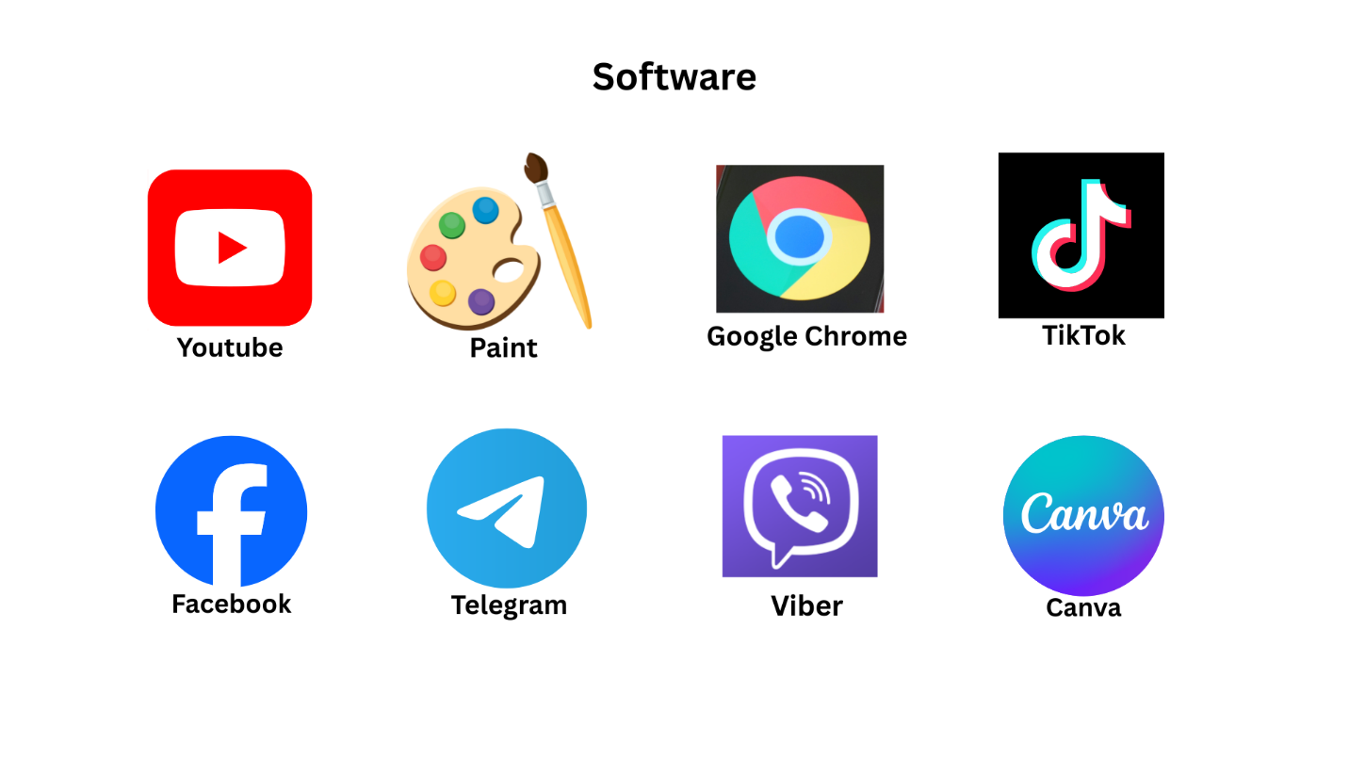

Input and Output Devices

Input Device
Input devices are tools we use to put information into the computer.
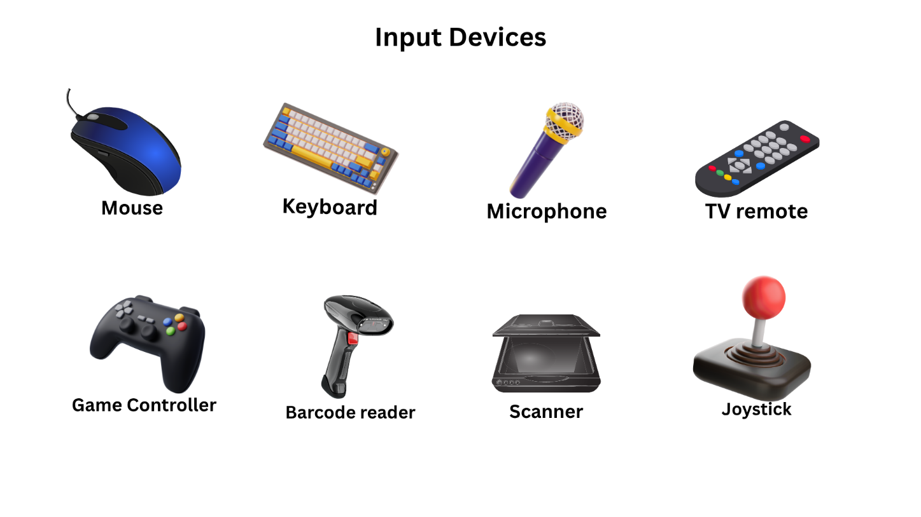
Output Device
Output devices are tools that show or give out information from the computer.
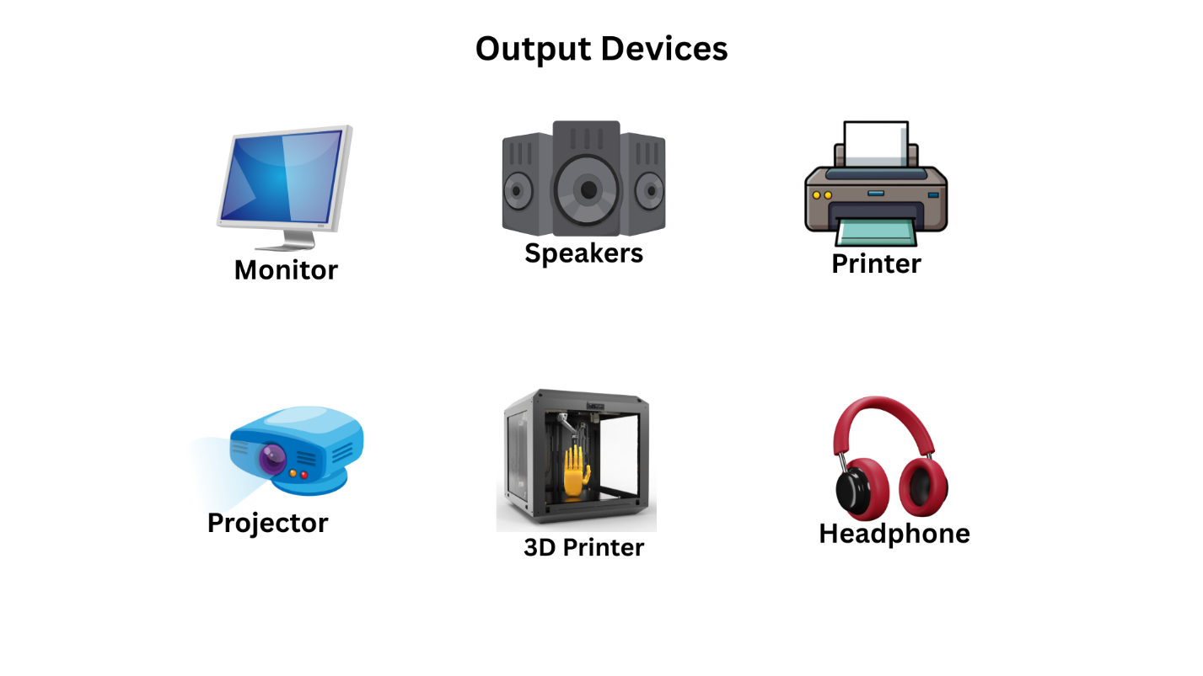
Digital Technology and Citizenship
How to Stay Safe Online
When we use the internet, we need to be careful and smart. Just like in real life!

1. Keep Personal Information Private
Don’t share your:
- Full name
- Home address
- School name
- Phone number
- Passwords
- Birthday
- Photo of yourself
Only your parents or guardians should know these.

2. Talk to a Trusted Adult
If you see something strange, scary, or confusing online,
Tell your teacher, parent, or guardian right away.

3. Don’t Talk to Strangers Online
People online are not always who they say they are.
Only chat with people you know in real life.

4. Use Strong Passwords
Use secret passwords with letters, numbers, and symbols.
Never tell anyone your password (except your parents).

5. Visit Safe Websites
Use Safe Search or child-friendly websites your teacher or parents recommend.

